Assignment 1

1. Install Power BI Desktop and share the final screenshot of the report view page which appears when power desktop starts.

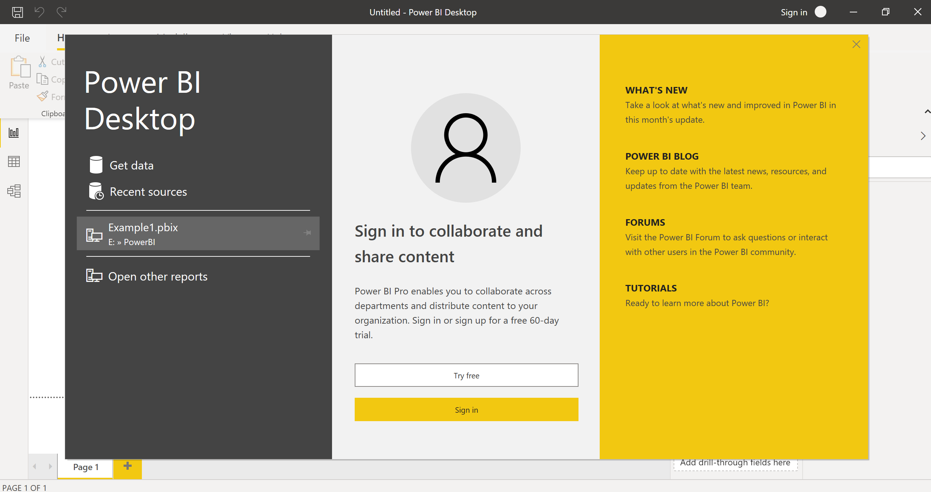

1. Prepare a document and with the following screenshot

− Report View

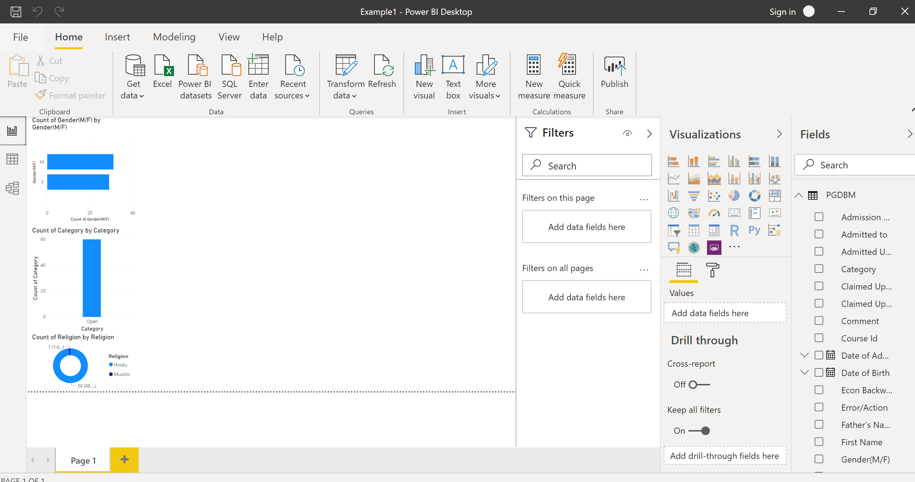

− Data View

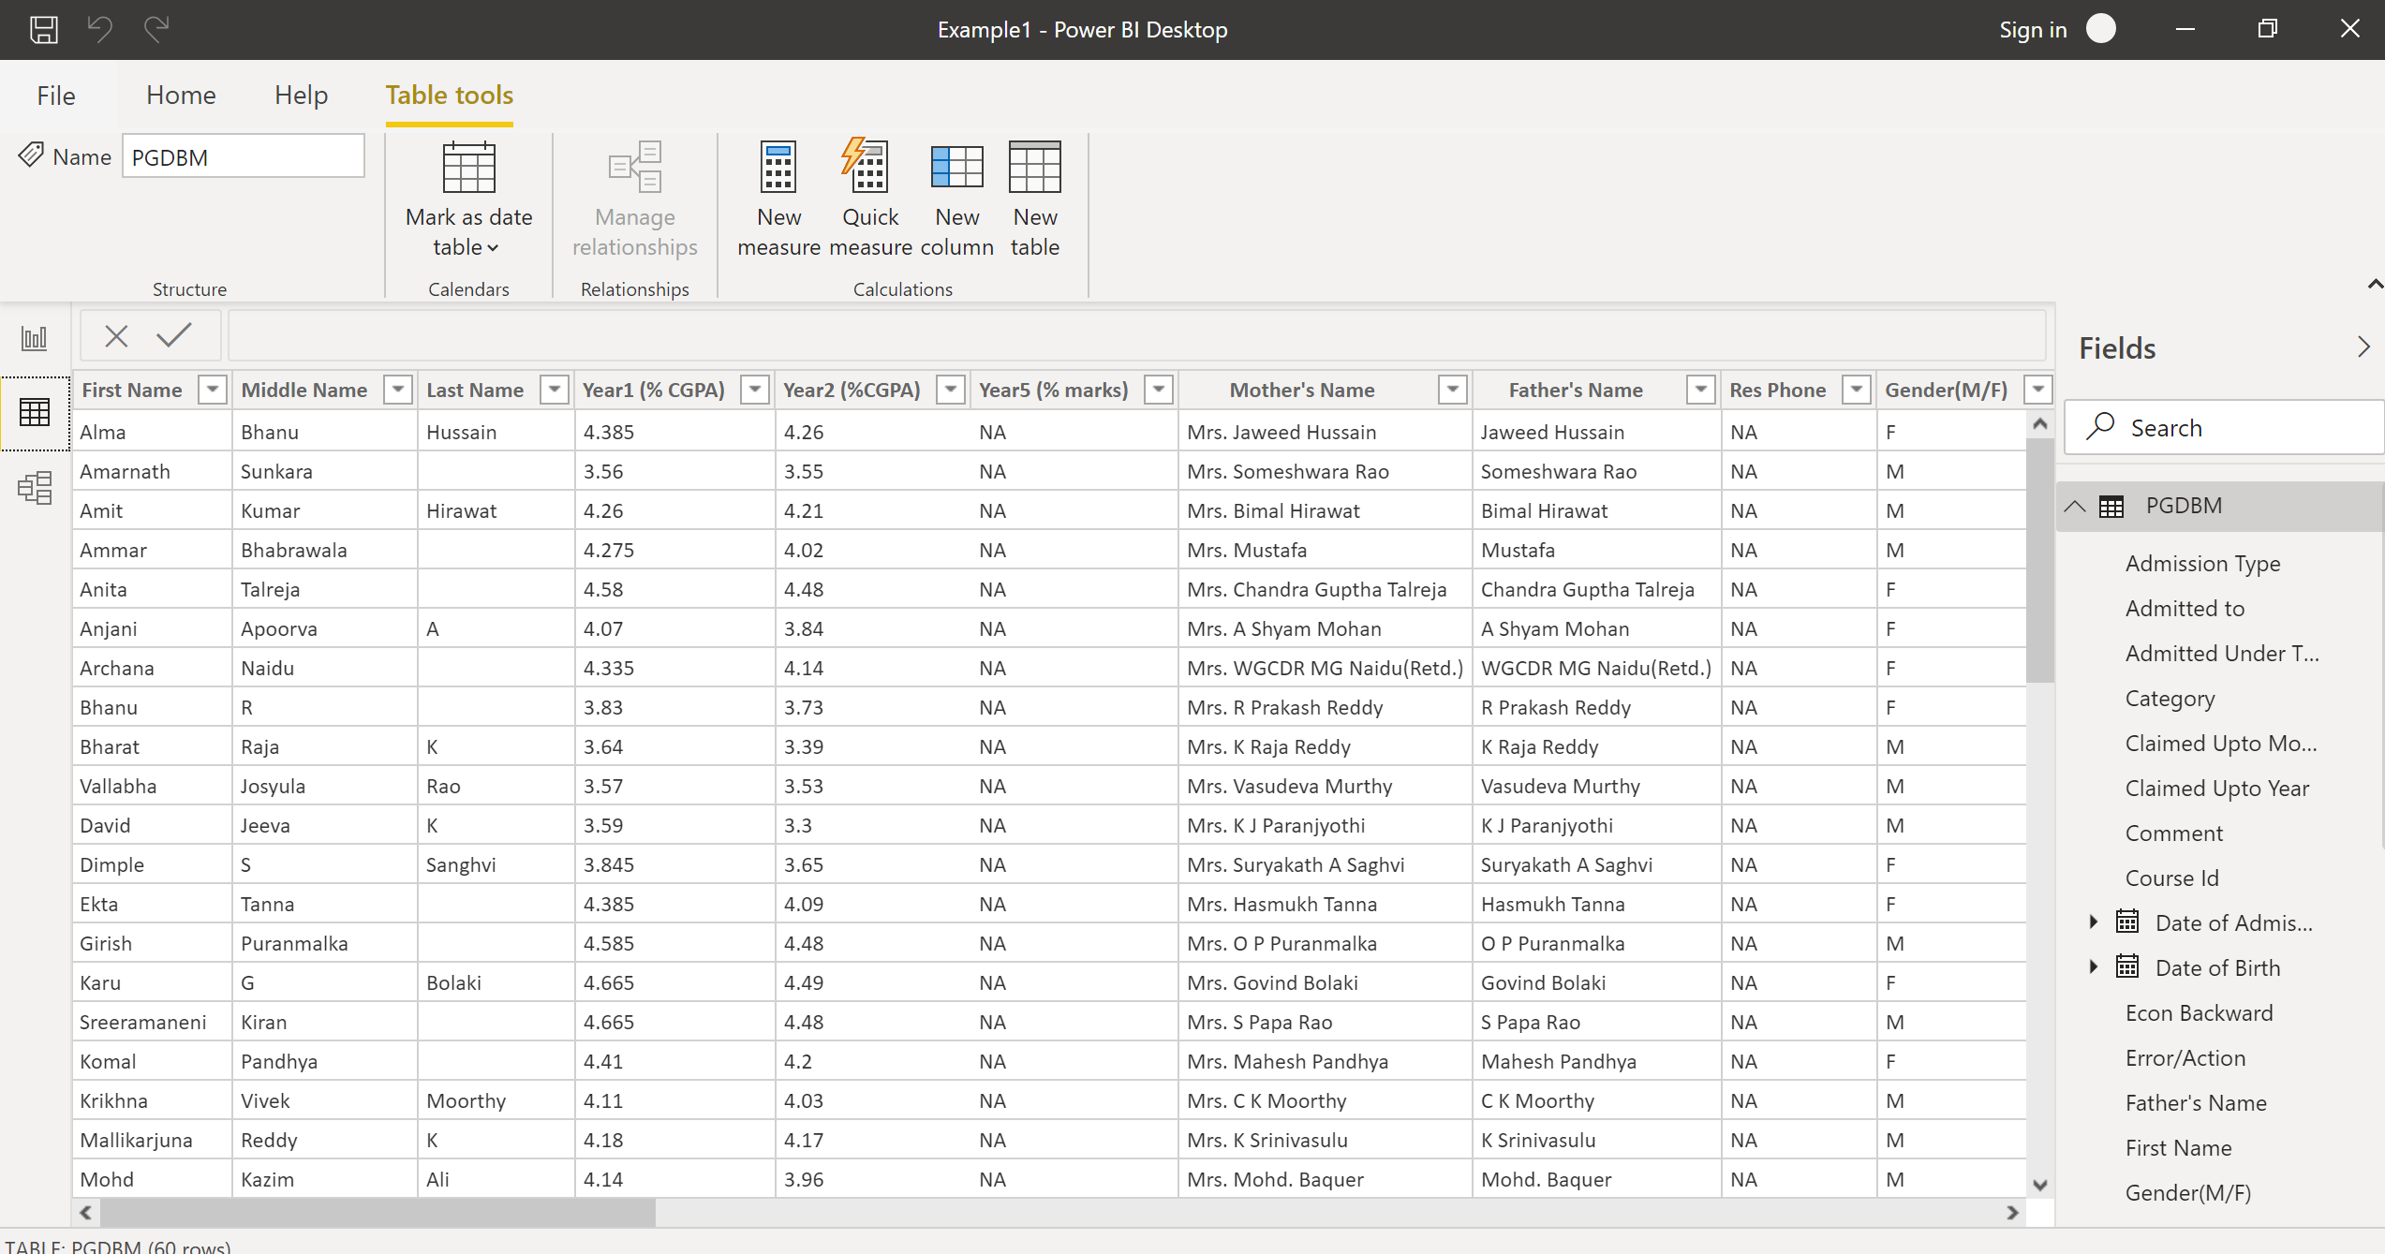

− Model View

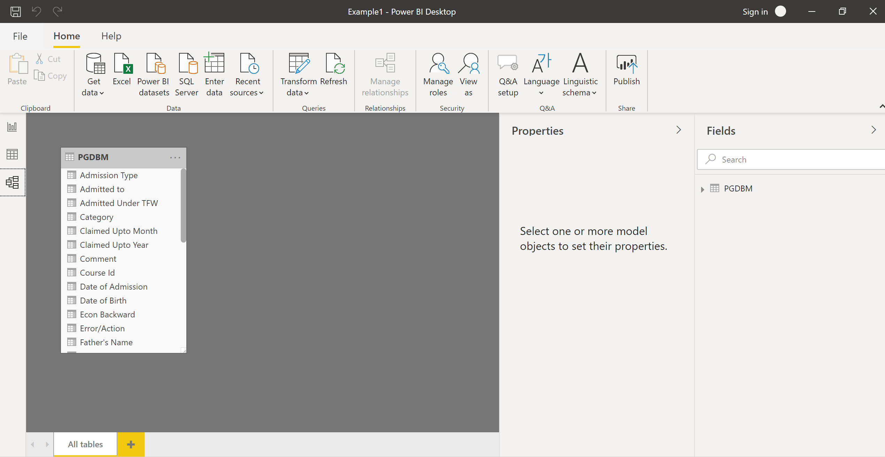

− Power Query Editor

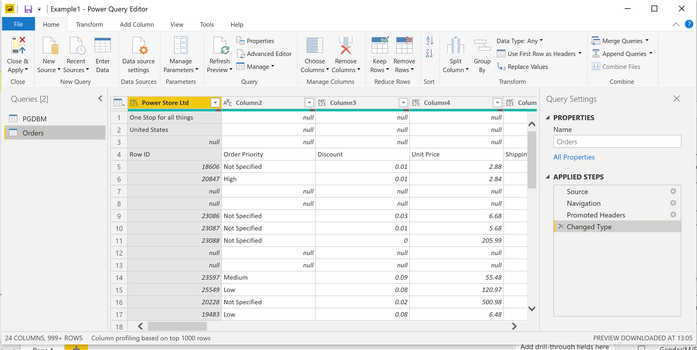

− Advance Editor

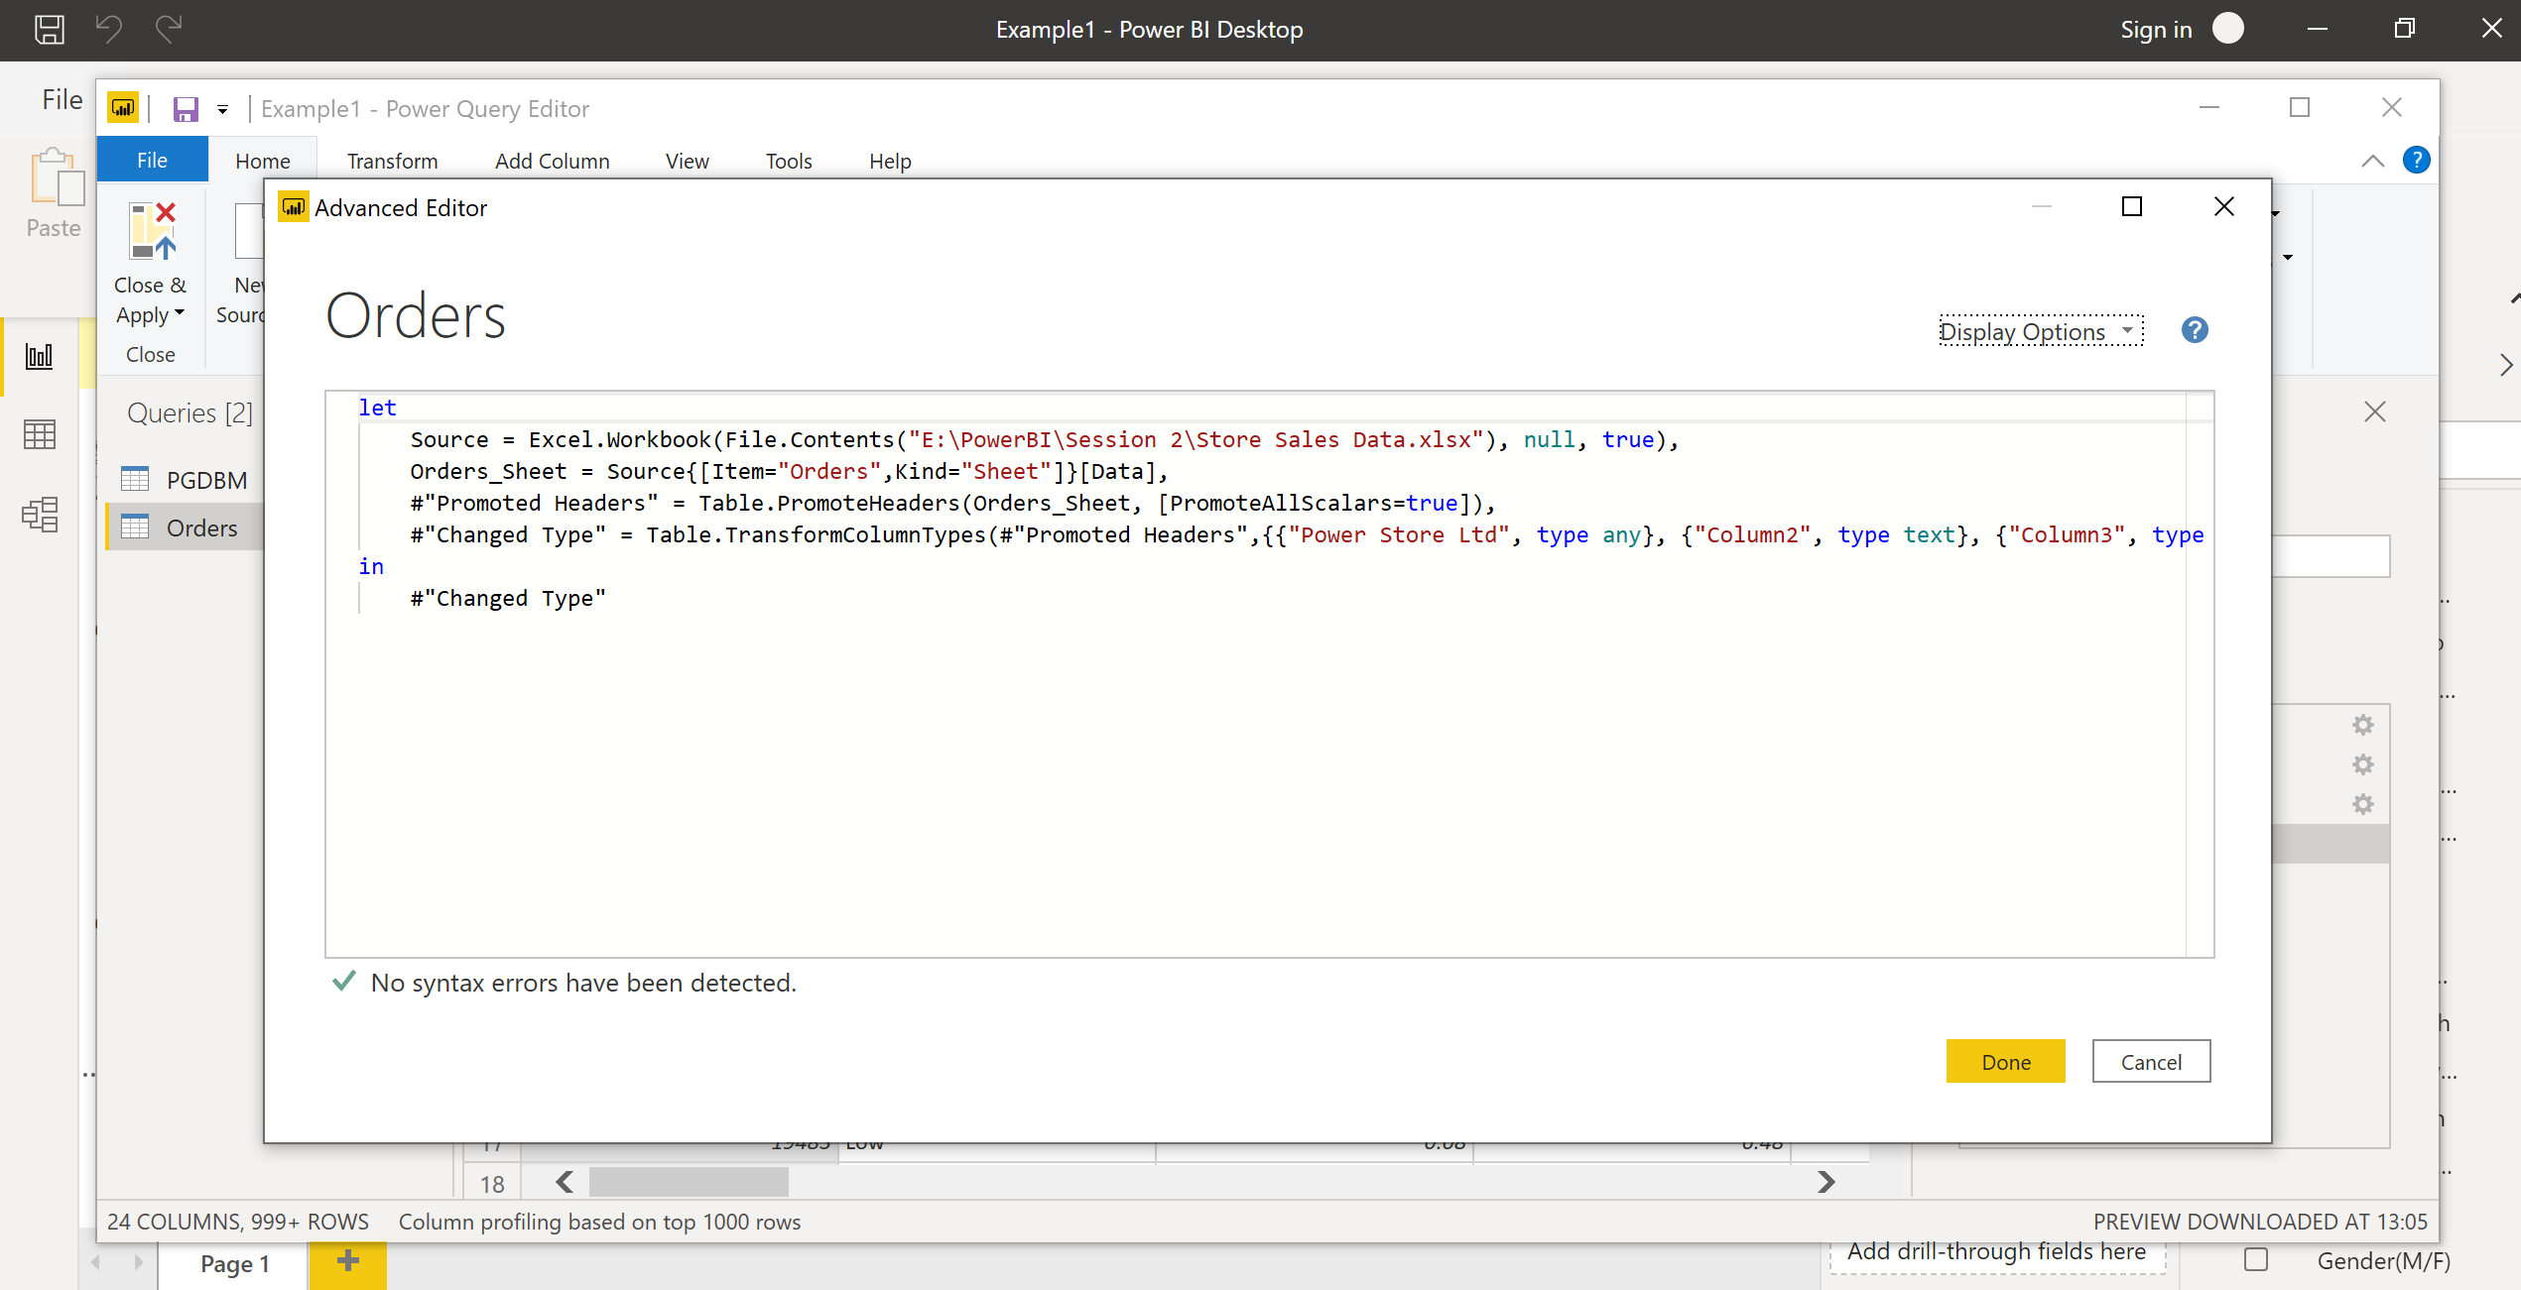

1. Prepare a document with details of the following along with their price

**− Power BI Desktop**

Free per individual users

**− Power BI Pro**

$9.99 – Monthly price per user

**− Power BI Premium**

$4,995 - Monthly price per dedicated cloud compute and storage resource with annual subscription